DANSA Lab – Weekly Progress Report

Prepared by: Ahmed Azmaine Alvee

Date: October 24, 2025

Affiliation: Undergraduate Research Assistant, DANSA Lab

Program: PURE Summer Research Program

Link: https://ucalgary.ca/experiential-learning/undergraduate-research/pure

2. Website Development Progress
- Sections Completed:
  - Home Page: Developed and designed to serve as the primary landing page. It includes lab introduction, mission statement, and a visual hero section for improved engagement.
  - Team Section: Showcases all current DANSA Lab members, including researchers, faculty, and collaborators, with uniform profile cards and professional layout.
- Technical Details:
  - The website structure is fully coded in HTML, CSS, and JavaScript.
  - CSS styles are modularized in site.css for maintainability.
  - Images and layout are optimized for accessibility and responsive display.
- Design Improvements Made:
  - Enhanced transparency of the background for better visual balance.
  - Enlarged team member photos for better visibility and aesthetic uniformity.
  - Refined typography and spacing for a cleaner user interface.

3. PURE Program Enrollment
- Successfully enrolled in the PURE (Program for Undergraduate Research Experience) at the University of Calgary.
- The selected research topic focuses on health-related computational approaches, which aligns with DANSA Lab’s interdisciplinary work in data analytics and system design.
- The PURE program link and application reference:
https://ucalgary.ca/experiential-learning/undergraduate-research/pure

4. Upcoming Goals
- Next Week’s Objectives:
  - Add a Publications Page to the website.
  - Begin drafting the research summary for PURE documentation (Health-focused project scope).
  - Integrate a consistent color palette across all pages for brand identity.
  - Prepare an interactive “Contact” section with social and academic profile links.

5. Reflections
Developing the DANSA Lab website has strengthened understanding of user-centric design and academic web presentation. The PURE program enrollment marks a significant milestone toward contributing to the university’s ongoing health research efforts.

6. Attachments
- Screenshots of the current Home and Team sections.
- Link to the PURE program page for reference.
- Professors:
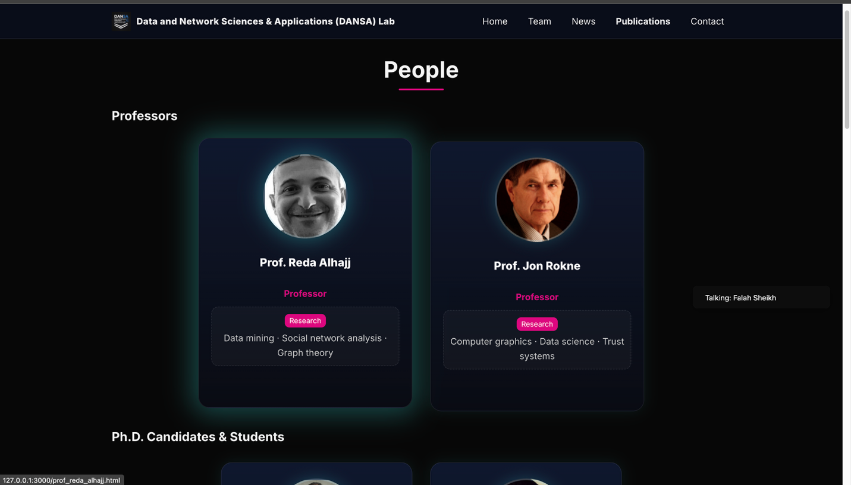

Home: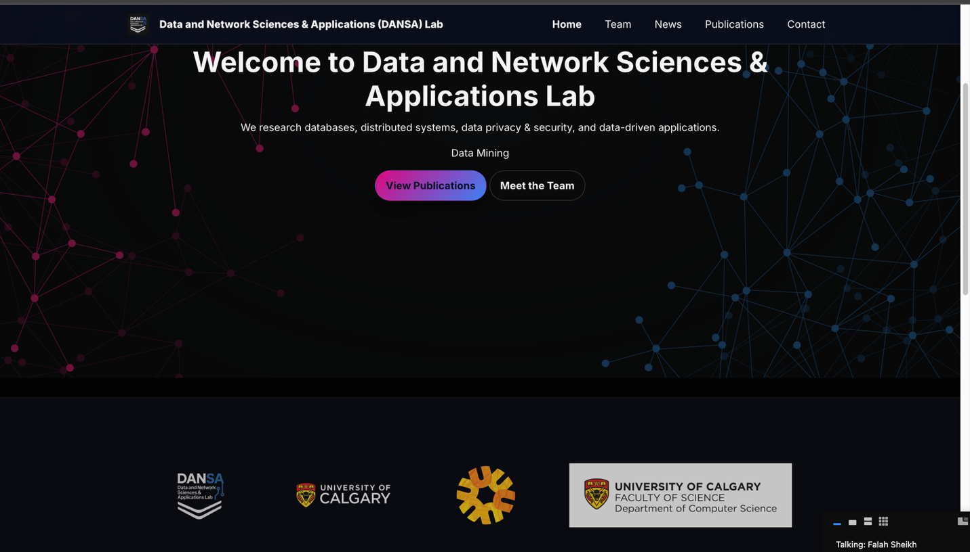

Team:
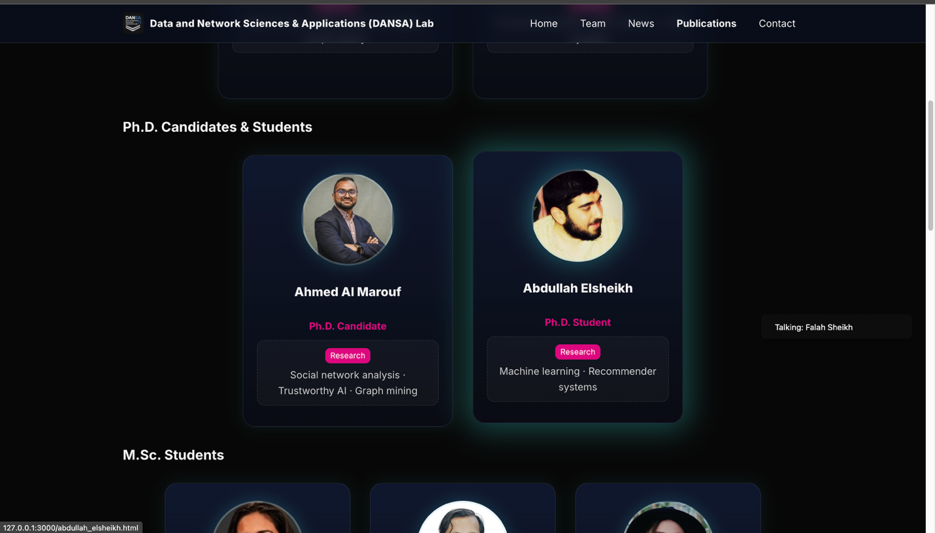
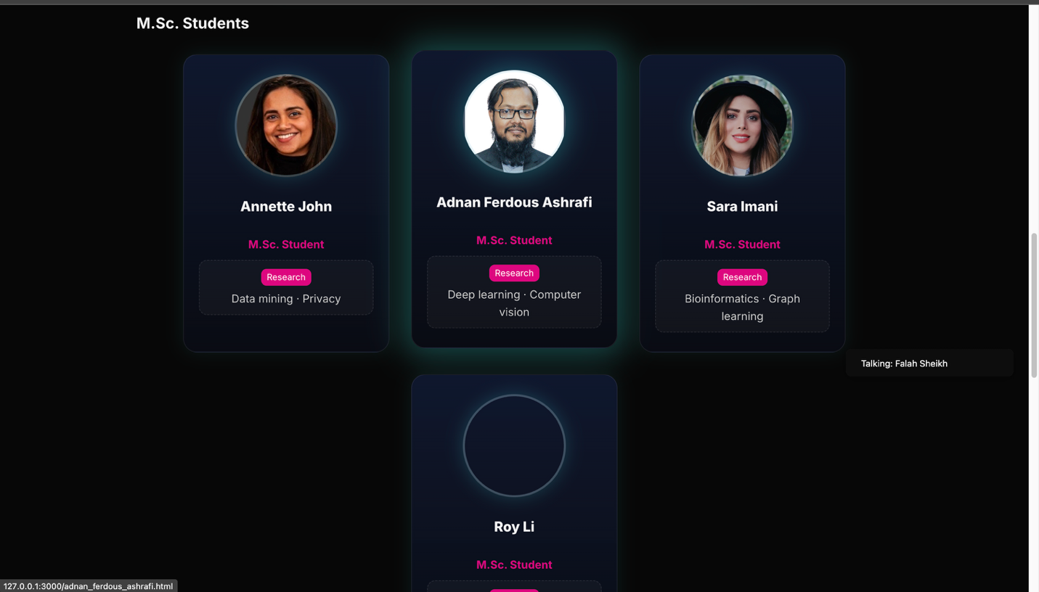

Publications:
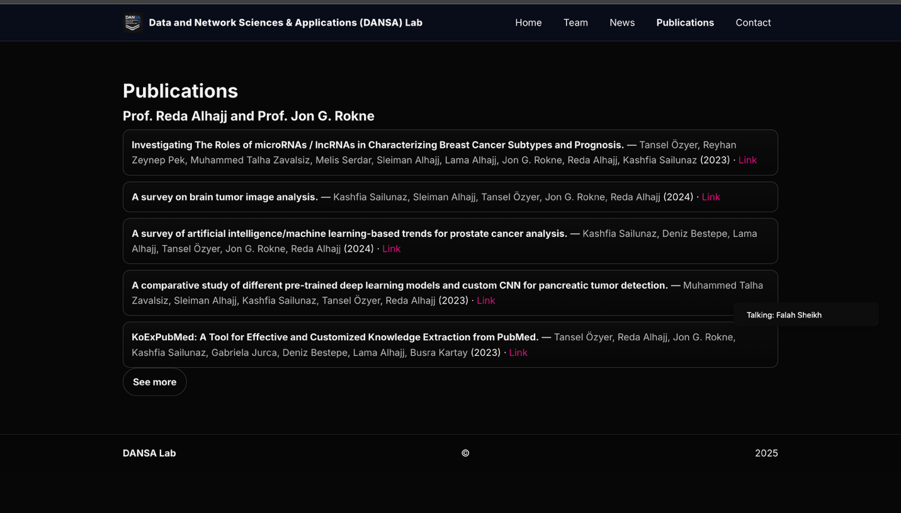

Contacts:
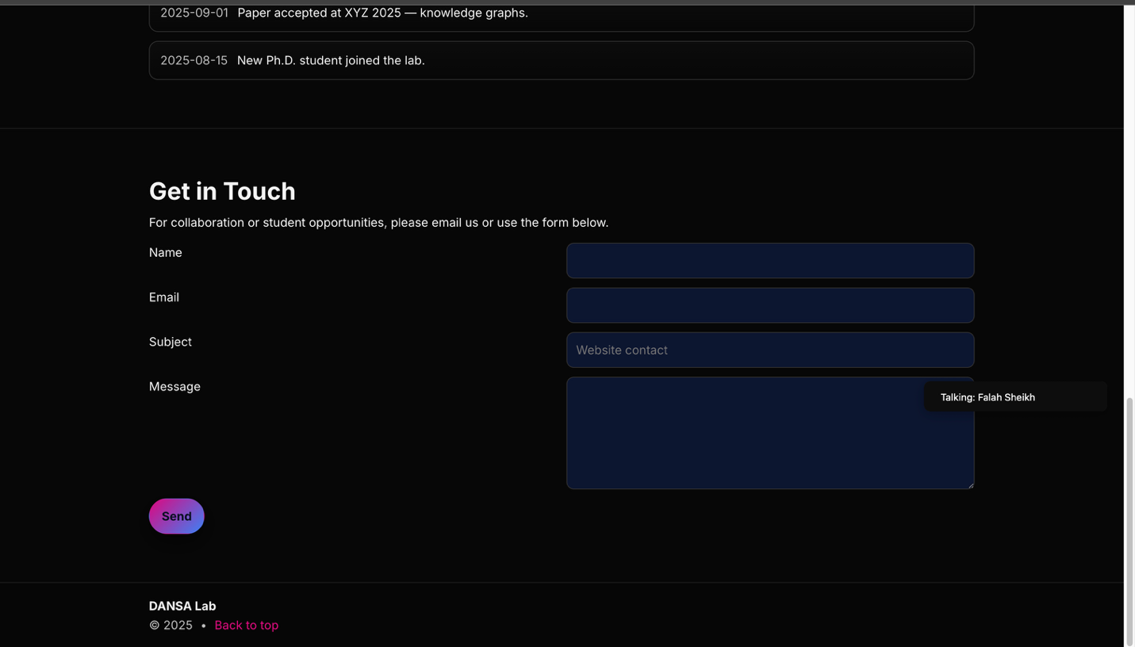

Biography: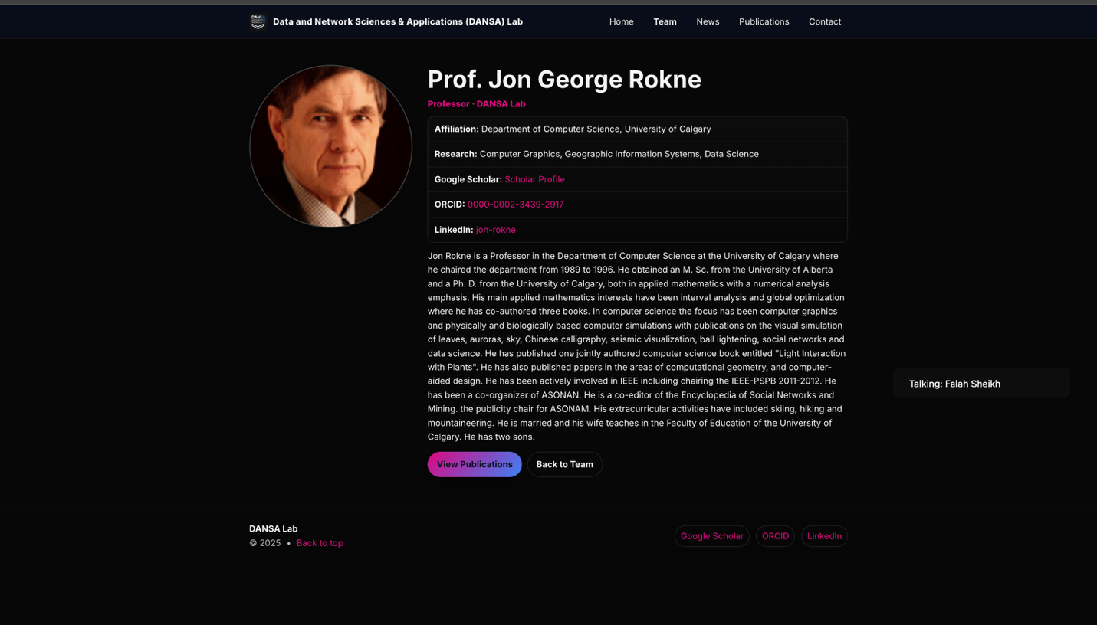
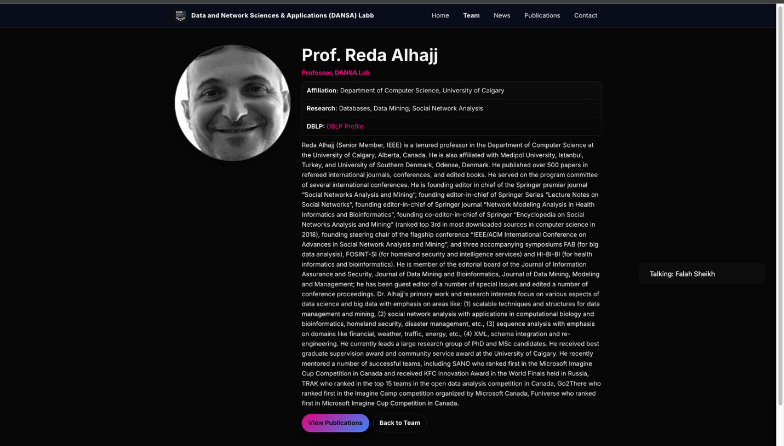

News:



